R1A3 Frequently Asked Question Task

I responsible to complete Frequently Asked Question user story, which including subtask:

* Generate FaQ Table.
* Creating Customer FaQ View (Function & Design).
* Manager FaQ Management (listing, showing, add, edit delete).
* FaQ Test Case. (Showed in R1A4 - Testing)

FaQ is important to allow Customer find answer for general questions that confusing them.

Below shows how do I complete the task (All the code is included in FaQ code folder[not runnable]) :

1. FaQ should contain two models, which is Main Lists (Category), and Sub Lists (Content):
   1. FaQ Main Lists
      1. Run Rails command “$Rails generate model FaQMainList FaqMainName:string” to generate FaQ Main Lists Table.

Run Rails command “$Rails generate model FaQSubList SubFaqQuestion:string SubFaqAnswer:text FaqMainLstId:integer”

* + 1. Run command “$rake db:migrate” to push updates to schema.
    2. Include validation in model.

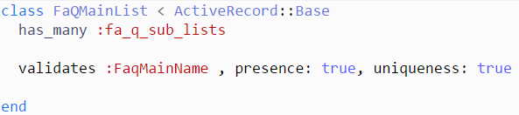

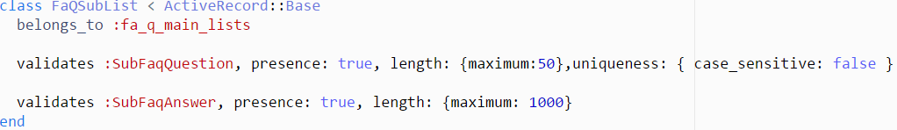

* + 1. Include resources in routes.rb



* + 1. Add In controller and html

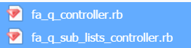

FaQ Controller

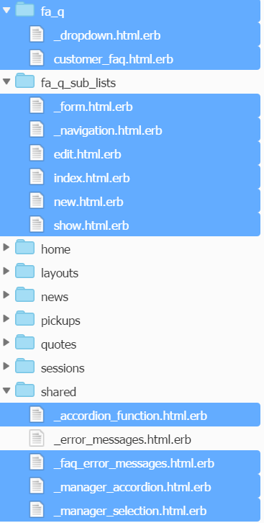

FaQ html

* + 1. Import and use accordion function to simple user interface.

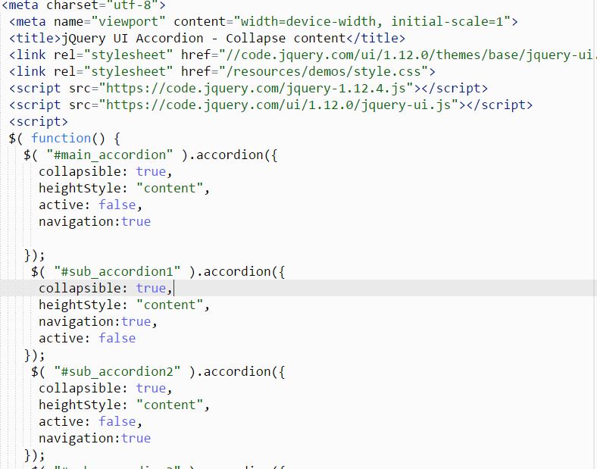

* + 1. Design interface with CSS.

